**Day 2:**

**Gene Annotation**

Protein Name: MBL2

Protein ID - 4153

**Find the following Gene function details**Location- Chromosome 10 Start - 144 and end- 246,

Family- Lectin C,

Clan- CL0056,

Domain- Lectin C type,

Motif,

E value- 2.7e-20 and

Description of function

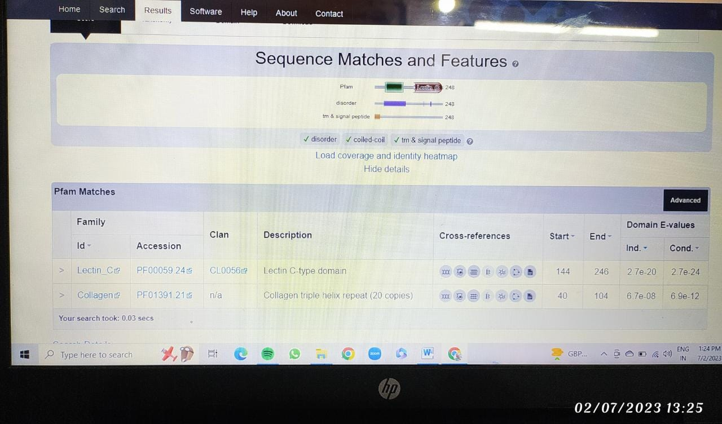

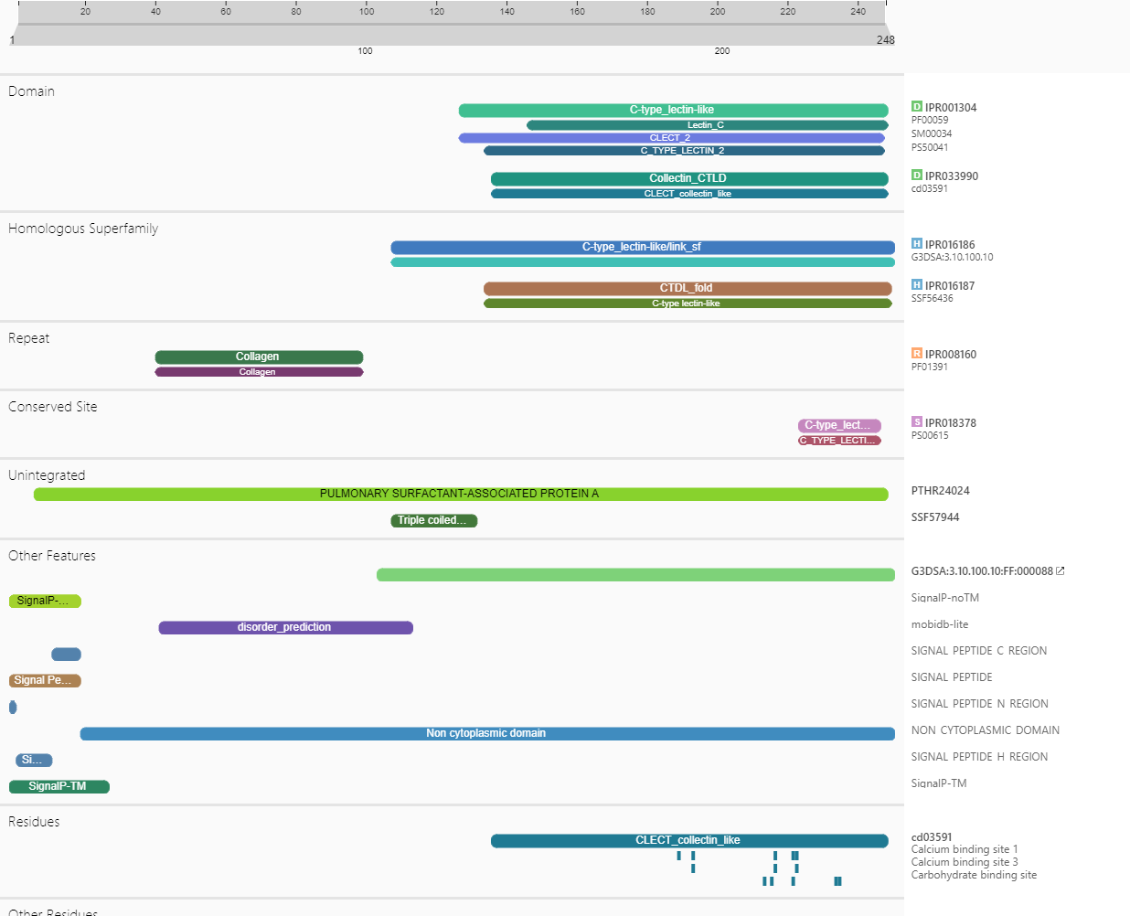

**Day 3: Phylogenetics**

**Construct a Phylogenetic tree for components of Corona virus.**

You can choose any gene/protein/component associated with Corona virus for atleast 5 different species/variants. Add the screenshot of the tree here.

GENE/Protein – IL6 interleukin 6 [ Homo sapiens (human) ]

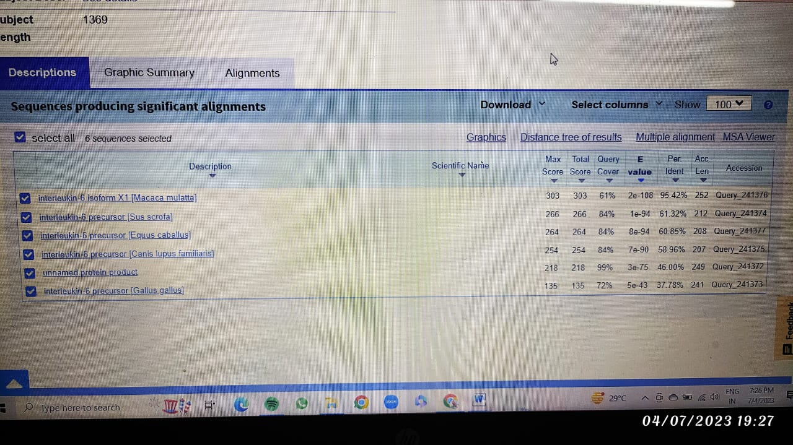

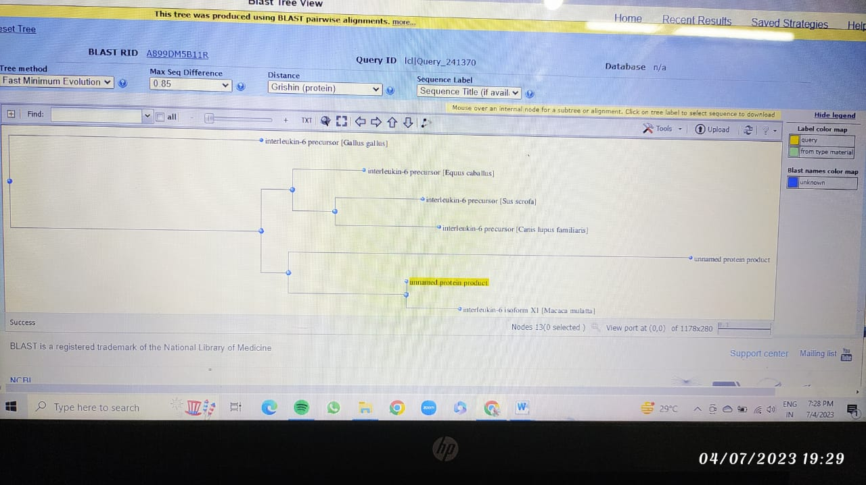

**Day 4:**

**Genome name( the one of your interest):*Plasmavirus2***

**From RAST results:**

*Mention the desired nucleotide sequence that you choose to perform BLAST on and fill in the following:*

1. Nucleotide sequence -gacccatcacctttaaatggattatggaaaggtgcatctgagttcatctttactggtgcattaatccttgttgcaggaataataataaaatttgtattttttagaaaaagaaaggtggggttctaa
2. Location on the genome- L13696.1_3_128
3. Start and end nucleotide -3 (start) and 128(end)
4. Function -Phage capsid and scaffold

**Perform a BLAST on the nucleotide sequence and paste a screenshot of the obtained BLAST results:**

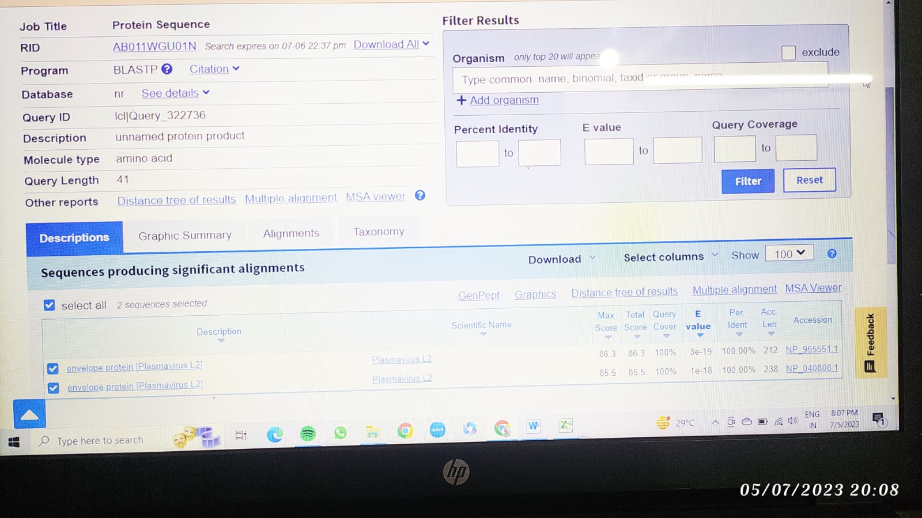

**Day 5 & 6:**

**Molecular Docking**

Protein Name: Cryo-EM structure of SARS-CoV2 RBD- ACE2 Complex

Protein ID – 7da

|  |  |  |  |  |
| --- | --- | --- | --- | --- |
| Ligand Name | Ligand ID | Follows Lipinski Rule? | Energy value | Dock Image |
| Oseltamivir | 65028 | Yes | -5.8 |  |
| Tenofovir | 464205 | Yes | -6.6 |  |
| Remdesivir | 121304016 | No | -8.2 |  |

**Day 7:**

**Day 8 & 9: Homology Modelling:**

You can choose any protein which is involved in SARS CoV-2 Pathogenesis (Eg: ACE2 receptor, Any envelope protein) and can take at least 2 homologous sequences with sequence similarity >30%. Try to develop an hypothesis around it (Like Why you want to use Homology modelling for your protein of interest, Purpose and outcome of it) and more importantly how it is going to add value to your hypothesis.

**Protein:** Angiotensin-converting Enzyme 2

**Gene:** ACE2

**PDB:** Q9BYF1 (First Isoform)

|  |  |  |
| --- | --- | --- |
| **Target** | **Sequence** | **Result** |
|  |  |  |

**Day 10:**

Please paste your GitHub account link: https://github.com/Smita271/BI-Internship23